User Manual for Helth & Fitness

1. Table of Contents

1. Introduction

- Welcome Message

- Purpose of the App

- Key Features Overview

2. Getting Started

- System Requirements

- Installation Guide

3. Navigating the App

- Overview of the User Interface

- Menu and Navigation Structure

- Customization and Personalization Options

4. Using the Features

- Exercise and Workout Guidance

- Daily Exercise

- Workout Plans and Programs

- Tracking Workouts

- Nutrition and Diet Tracking

- Food Database

- Calorie Tracking

- Progress Tracking and Analytic

- Monitoring Progress

- Setting Goals

- Analyzing Statistics

5. Troubleshooting

- Common Issues and Solutions

- Frequently Asked Questions (FAQs)

6. Safety and Guidelines

- Safety Recommendations during Exercise

- App Usage Guidelines

- Terms of Use and Privacy Policy

7. Support and Contact Information

- Customer Support Contact Details

- Feedback and Suggestions

========================================================================

1. Introduction

A. Welcome Message

Welcome to Helth & Fitness! This user manual is designed to guide you through the features and functionality of our fitness app, ensuring you get the most out of your fitness journey.

B. Purpose of the App

Helth & Fitness is a comprehensive tool designed to assist you in achieving your fitness goals by providing workout guidance, nutrition tracking, progress monitoring, and more.

C. Key Features Overview

This section provides an overview of the primary features available in the app, giving users a glimpse of what they can expect and explore.

- Exercise and Workout Guidance

- Nutrition and Diet Tracking

- Progress Tracking and Analytic

1. Getting Started

A. System Requirements

Before installing Helth & Fitness, ensure that your device meets the following system requirements:

- Operating System: Compatible with Android 7.0 (Nougat) or later

- Device Compatibility: Compatible with Android smart phones and tablets

- Internet Connection: Required for initial setup and accessing online features

B. Installation Guide

Android Devices (Smart phones, Tablets)

a. Open the Google Play Store on your device.



b. Search for "[Your Fitness App Name]" in the search field and select the app.

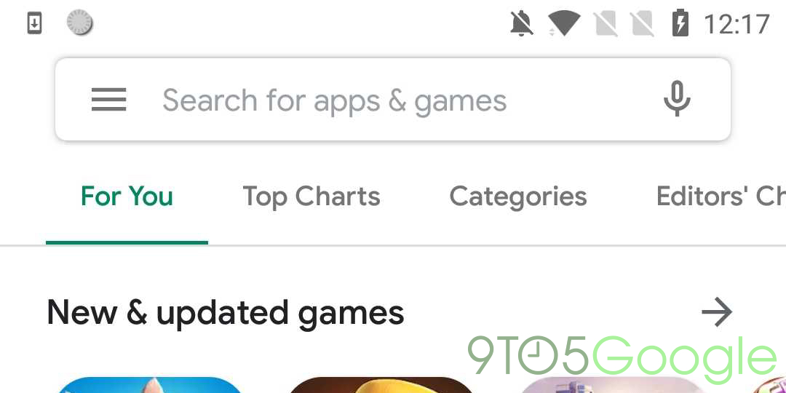

c. Tap the "Install" button and allow the app to download and install on your device.

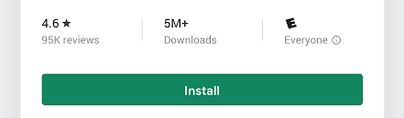

d. After installation, open the app and continue with the registration process.

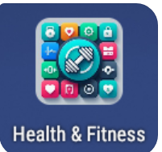<- app icon

1. Navigating the App

A. Overview of the User Interface

Helth & Fitness features a user-friendly interface designed to provide easy access to its various functionality. Here's an overview:

a. Home Screen

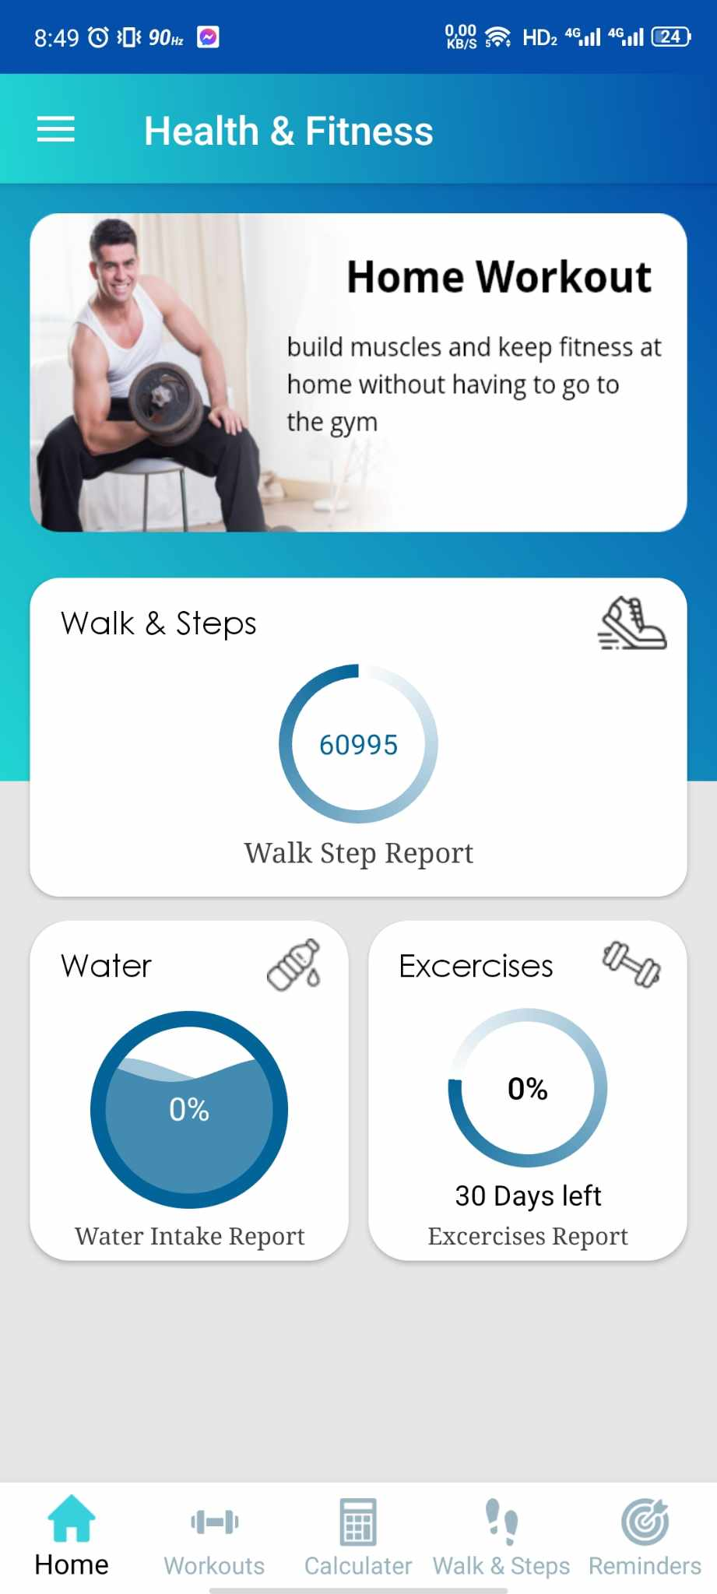

- Upon logging in, you'll land on the home screen/dashboard.

- The home screen displays a summary of your daily activity, including workouts, calorie intake, progress stats, etc.

- Access primary features, such as workouts, nutrition, progress tracking, etc., through intuitive menu options.

b. Menu and Navigation Structure

- Navigation Bar:*Located at the bottom of the screen, it includes icons for quick access to major sections like "Workouts," "Calculator," "Walk&steps," etc.



- Sidebar/Menu: Tap the menu icon (represented by three horizontal lines icon) to access additional features, settings, and account options.



c. Customizing Workouts and Nutrition Plans

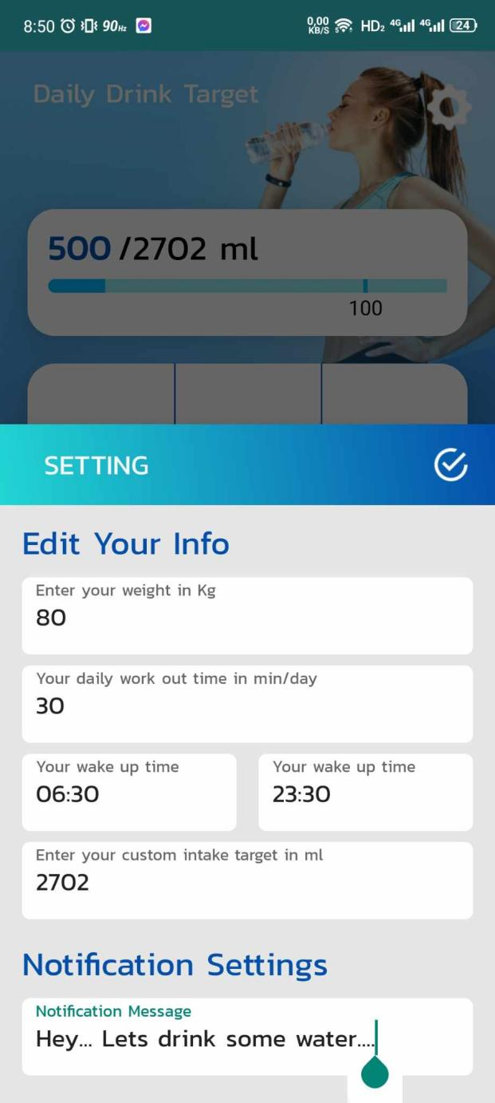

- Access pre-designed workout plans or create custom workouts tailored to your preferences and fitness level.

- Plan daily workout, calorie intake, and set get up time.

4. Using the Features

A. Function Workouts (Instruction with Animation)

Accessing Workouts

- Workout Library: Explore the "Workouts" section to find a variety of exercises categorized by muscle groups, equipment, or workout types.

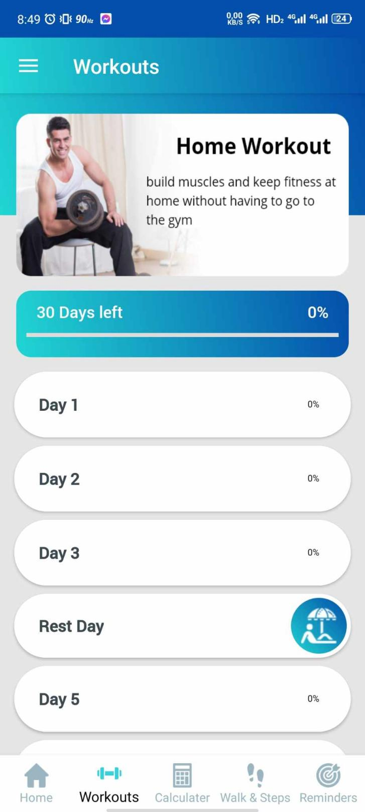

- Exercise Details: Tap on any exercise to access detailed instructions, including proper form, technique, and recommendations.

Animated Instructions

- Visual Guidance: Animated demonstrations illustrate exercise techniques, providing step-by-step instructions for each movement.

- Repeat Gif: Replay animations to ensure you understand and perform exercises correctly.

B.Calculators

Health Metrics Calculator

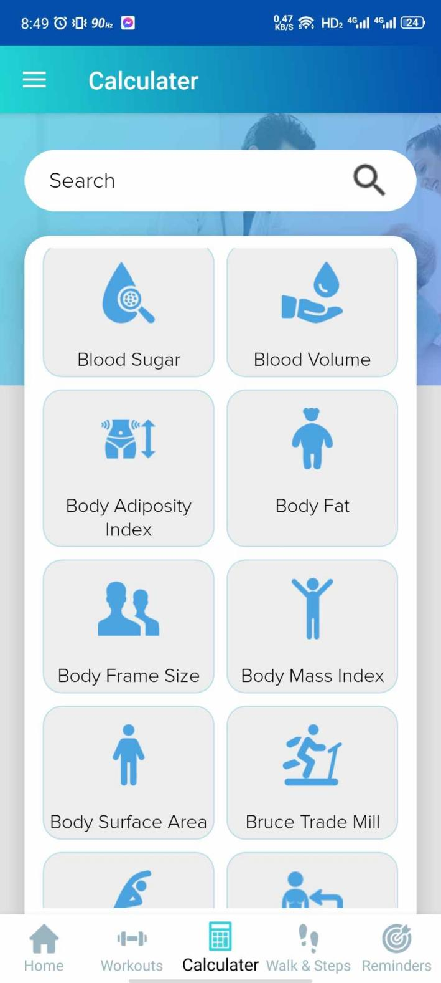

- Blood Pressure: Use the blood pressure calculator to input systolic and diastolic readings for instant analysis and tracking.

- Calories Burned: Input exercise duration, intensity, and body weight to estimate calories burned during workouts.

- Body Fat Percentage: Calculate body fat percentage based on measurements for monitoring changes.

C. Walks & Steps

Step Tracking

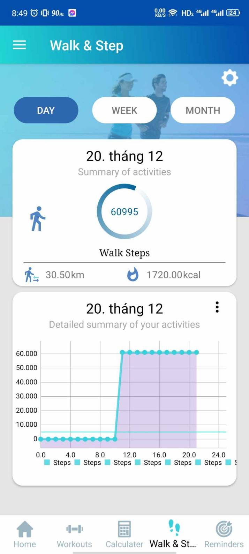

- Automatic Tracking: The app tracks steps throughout the day, providing real-time updates on the number of steps taken.

- Daily Progress: View step counts and daily walking progress in a user-friendly interface.

D. Reminders

Setting Workout Reminders

- Customizable Alerts: Set reminders for workout sessions or exercise routines.

- Frequency and Time: Personalize reminders by scheduling specific times and days to suit your routine.

Note:

- Animated instructions aim to guide users visually through exercise techniques and form.

- The health metrics calculator provides quick estimations for various health-related data.

- Walks & Steps feature encourages users to stay active by monitoring daily steps.

- Reminders ensure users stay consistent with their workout schedules.

5. Troubleshooting

A. Common Issues and Solutions

App Crashes or Freezes

- Restart the App: Close the app and reopen it to resolve minor glitches or temporary freezes.

- Device Restart: Restart your device, as this can often resolve performance issues.

Syncing and Data Problems

- Check Internet Connection: Ensure a stable internet connection to facilitate data syncing between the app and servers.

- Refresh or Sync Data: Manually sync data in the app settings to update recent changes or entries.

B. Frequently Asked Questions (FAQs)

Q: I can't find a specific exercise in the library. What should I do?

- A: Our exercise library is regularly updated. If you can't find a specific exercise, try using different keywords or check for similar exercises under related categories.

#### Q: I'm not receiving reminders for my scheduled workouts. How can I fix this?

- A: Ensure the app has the necessary permissions enabled for sending notifications. Go to app settings and enable notifications for reminders.

Q: I'm experiencing inaccuracies in step counting. What should I do?

- A: Step counting may vary based on device sensitivity and calibration. Try adjusting the step tracking settings or ensure the device is securely attached while walking.

Note:

- Troubleshooting steps provided here address common issues users might encounter while using the app.

- Encourage users to reach out to customer support or check the app's website for further assistance if issues persist.

6. Safety and Guidelines

A. Safety Recommendations during Exercise

Warm-Up and Cool Down

- Importance: Always begin workouts with a warm-up to prepare your body and end with a cool-down to ease muscles.

- Duration: Aim for 5-10 minutes of light cardio or dynamic stretching before starting intense exercises.

Proper Form and Technique

- Exercise Correctly: Perform exercises with proper form and technique to reduce the risk of injury.

- Consult Professionals: Seek guidance from fitness experts or trainers if unsure about proper exercise execution.

Rest and Recovery

- Rest Days: Incorporate rest days into your routine to allow your body to recover and prevent over-training.

- Listen to Your Body: Pay attention to signals of fatigue, discomfort, or pain during workouts. Stop if necessary and seek medical advice if needed.

B. App Usage Guidelines

User Responsibility

- User Awareness: Understand that the app provides guidance and information, but individual responsibility for exercises and workouts lies with the user.

- Health Considerations: Consult a healthcare professional before starting any new exercise or diet program, especially if dealing with health conditions or injuries.

Privacy and Data Security

- Data Privacy:* Your personal information and data security are our priorities. Refer to our Privacy Policy for detailed information on data handling and security measures.

App Limitations

- App Assistance: The app serves as a tool for fitness guidance but may have limitations. It's not a substitute for professional advice, diagnosis, or treatment.

C.Terms of Use and Privacy Policy

Agreement and Consent

- Acceptance: By using the app, users agree to abide by the Terms of Use and Privacy Policy outlined by the app.

- Read Carefully: Familiarize yourself with the terms, conditions, and policies governing app usage and data handling.

Note:

- Safety guidelines aim to promote injury prevention and responsible app usage.

- Users should prioritize their safety and consult professionals for personalized fitness advice or medical concerns.

7. Support and Contact Information

A. Customer Support

Contacting Support

- Email Support: For any inquiries, feedback, or issues, reach out to our customer support team at support@FittnesTrackingAppG.com.

FAQ Section

- Resourceful Information: FAQs cover various topics related to app usage, troubleshooting, and general inquiries.

B.Feedback and Suggestions

Sharing Your Thoughts

- We Value Your Feedback: We appreciate your input to enhance our app experience. Share your suggestions, feature requests, or thoughts via email or app feedback forms.

- Improvement Opportunities: Your feedback helps us improve and tailor the app to better meet your needs.

Social Media and Community

- Follow Us: Connect with us on social media platforms for updates, tips, and community engagement related to fitness and health.

Note:

- Contact information provided here offers multiple channels for users to seek assistance or share feedback.

- Encourage users to utilize these channels for any queries or suggestions, fostering a collaborative and supportive user community.